NAME: TASNEEM SADIKOT
PRN:23070521162
SEC: B
Using ODBC (Open Database Connectivity) for Database Operations
ODBC allows applications to interact with databases like Oracle, MySQL, SQL Server, etc., using a standardized API. Below, I'll show how to connect to a database and perform basic operations using ODBC in Python.

By using PYTHON
Download Python
- Go to the official Python website: https://www.python.org/downloads/
- Click the "Download Python" button (this will download the latest version)
Install Required Packages
First, install the pyodbc library (for Python):
To install above
- Win + X, then click Windows Terminal
- pip install pyodbc
- python -c "import pyodbc; print(pyodbc.version)"

ODBC Connection Setup
To use ODBC, configure a DSN (Data Source Name) in your system:
- Windows: Go to Control panel → Windows tools (older versions of windows ADMINISTRATIVE TOOL)→ ODBC Data Sources (64-bit) → Add → Oracle in OraDb11g_home →
  - Data source name : orcl.
  - Description:
  - Tns service name:
  - User ID : sit2
→ click OK ( it will ask password : sit)

Python Code for ODBC Database Operations
The following Python program connects to a database via ODBC and performs CRUD (Create, Read, Update, Delete) operations.
- Python Script Using ODBC
import pyodbc

# Oracle DSN connection details
dsn_name = "Orcl" # Replace with your actual DSN
user = "sit2"
password = "sit"

try:
# Connect to Oracle using DSN
conn = pyodbc.connect(f"DSN={dsn_name};UID={user};PWD={password}")

# Create a cursor
cursor = conn.cursor()

# 1. Create Table
cursor.execute("Drop table acc")
cursor.execute('''
CREATE TABLE Acc (
Account_No INT PRIMARY KEY,
Holder_Name VARCHAR(100),
Balance FLOAT
)
''')
print("Table Acc created successfully.")

# 2️ Insert Data
cursor.execute("INSERT INTO Acc VALUES (101, 'Alice', 5000)")
cursor.execute("INSERT INTO Acc VALUES (102, 'Bob', 3000)")
conn.commit()

# 3️ Read Data
cursor.execute("SELECT * FROM Acc")
for row in cursor.fetchall():
print(row)

# 4️ Update Data
print("\nTable Acc before update.")
cursor.execute("SELECT * FROM Acc")
for row in cursor.fetchall():
print(row)
cursor.execute("UPDATE Acc SET Balance = Balance + 1000 WHERE Account_No = 101")
conn.commit()
print("\nTable Acc after update.")
cursor.execute("SELECT * FROM Acc")
for row in cursor.fetchall():
print(row)
# 5️ Delete Data
# cursor.execute("DELETE FROM Accounts WHERE Account_No = 102")
conn.commit()

# Close connection
cursor.close()
conn.close()

except Exception as e:
print("Error:", e)

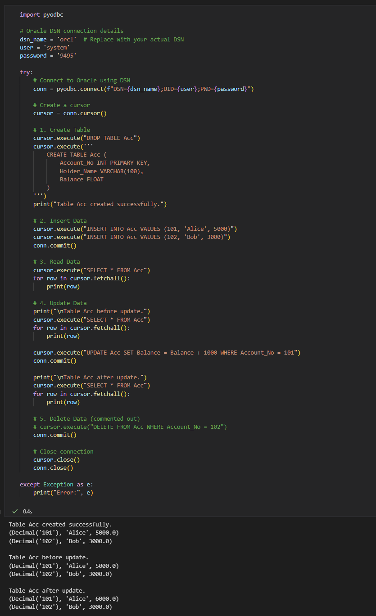
Explanation of Operations
- Connect to Database:
  - Uses pyodbc.connect() to connect using ODBC.
  - Replace your_server_name, your_database, your_username, and your_password accordingly.
- Create a Table (Accounts)
  - Defines columns: Account_No, Holder_Name, Balance.
- Insert Records
  - Adds sample data (Alice and Bob).
- Retrieve Records
  - Fetches all records and prints them.
- Update a Record
  - Increases Alice's balance by 1000.
- Close Connection
  - Closes the database connection to free resources.

